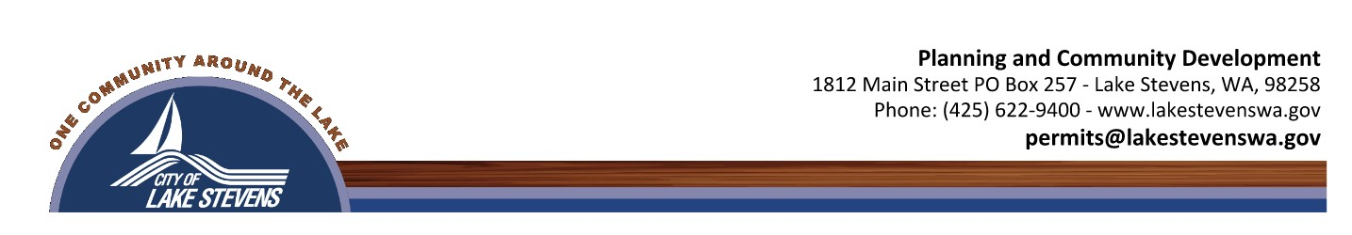

FINAL PLAT SUBMITTAL CHECKLIST

Please review LSMC 14.18.030-.055 content of the Final Plat in addition to the below. The city does offer a pre-check for the final plat (typically consisting of a survey and lot calculation review), and this may be submitted before final plat submittal and is subject to the final plat pre-check review fee. All documents must be uploaded in PDF format.

Required Submittal Items:
- The Master Land Use Application must be completed in Citizen Connect.
- Intake Fee (to be invoiced after the permit has been received)
- Title Report dated within the last 30 days containing the following:
  - A legal description of the total parcel sought to be subdivided
  - A list of those individuals, corporations, or other entities holding an ownership interest in the parcel
  - Any easements or restrictions affecting the property with a description, purpose, and reference the recording number
  - Any encumbrances, delinquent taxes, or assessments on the property
  - If lands are to be dedicated or conveyed to the City as part of the subdivision, an American Land Title Association title policy shall be required
- Plat document that complies with the approval by the Preliminary Plat. In addition to the items required for the preliminary approval, please provide the following:
  - Certification from a professional land surveyor, licensed in the State of Washington, as to the survey data, layout of streets, alleys, and other rights of way
  - The document must be suitable for recording a plat with the Snohomish County Recorder’s Office. Please contact the Recorder’s Office to confirm the current standards
  - Approval signature blocks for the owners, surveyor, City of Lake Stevens Planning Director, Public Works Director (for projects with public improvements or ROW dedications), City of Lake Stevens Treasurer, Snohomish County Treasurer, and Snohomish County Auditor
- Lot closure calculations
- Plat acceptance letters from PUD Water, PUD Electrical, and Lake Stevens Sewer District
- Bonds (submit estimates for approval of bond amounts with the permit for staff review and approval prior to ordering)
- An approved subdivision name reservation from the Snohomish County Auditor’s Office (does not apply to short plats/subdivisions)
- Narrative stating compliance with the preliminary conditions of approval (Hearing Examiner Decision)
- As-builts are to be submitted in a PDF format for staff review and comments. Once the draft is approved, a final PDF is uploaded for the Public Works Director's signature. Then the digital files are to be on the NAVD 88 Datum and sent in “.dwg”, shapefiles, or other AutoCAD-compatible format per Lake Stevens Municipal Code (LSMC) 14.18.035(d), to engineering@lakestevenswa.gov. See As-Built checklist.
- The Planning Director may require the applicant to submit additional materials

*Final Plat applicants must submit their final plat documents to the Snohomish County Assessor’s Office for segregation review. This can be done during the City’s review of the Final Plat.

