This outline is for LPA and other governmental entities to report Title VI activities that occurred over the past year and report Title VI goals for the upcoming year. Reports must be returned on or before due date to meet eligibility requirements for federal funding. Send to TitleVI@WSDOT.wa.gov
DUE DATES: Refer to Section 28.3 for scheduled reporting period and due date May 1st yearly.
Contact Information
Name and title of administrator (signature on Standard Assurances): Gene Brazel, City Administrator
Mailing Address: 1812 Main St, PO Box 257
City: Lake Stevens WA Zip Code: 98258 County: Snohomish
Phone #: 425-622 -9400 email address: gbrazel@lakestevenswa.gov

Name and title of head of transportation-related services: Aaron Halverson, Public Works Director
Mailing Address: 1812 Main St, PO Box 257
City: Lake Stevens WA Zip Code: 98258 County: Snohomish
Phone #: 425-622-9403 email address: ahalverson@lakestevenswa.gov

Name and title of designated Title VI coordinator*: Max Roth, Risk Manager
Mailing Address: 1812 Main St, PO Box 257
City: Lake Stevens WA Zip Code: 98258 County: Snohomish
Phone #: 425-622-9400 email address: risk@lakestevenswa.gov
*When the Title VI coordinator changes, notify TitleVI@WSDOT.wa.gov within 30 days.
To comply with Title VI requirements, each annual report submission must include signed Standard Assurances (USDOT1050.2A).
Accomplishments
- Have there been any changes to the approved Title VI Plan that have not been reported to OECR?
No.
- Organization, Staffing, Structure: Describe the Title VI Program reporting structure including the Title VI Coordinator, Administrative Head, and transportation-related staff. The list should include name, race, color, and national origin of each individual. Include the same details if your LPA has a volunteer or appointed board related to transportation decision making.
Title VI Role/Title | Name | Race | Color | National Origin
Administrative Head | Gene Brazel | White | White | United States
Transportation Staff | Aaron Halverson | White | White | United States
Title VI Coordinator | Max Roth | White | White | Austria

- Community Demographics: Using a map of the LPA’s boundaries, describe the demographics of the LPA’s service area (e.g., race, ethnicity, and national origin). List, by individual languages, the percentage of the population who is Limited English proficient. If the LPA’s Limited English proficient population is 5% of the total population or 1,000 individuals, whichever is less, explain the Four-Factor Analysis by answering the statements listed on the next page.

According to the United States Census (2024), the racial composition of the city is predominantly White (75.5%), followed by Hispanic/Latino (11.2%), Mixed Race (11%), and Asian (7.8%). Fourteen percent of households speak a language other than English at home. Among these, Spanish is the most common non-English language, spoken by 1.3% of the population.
The majority of respondents are White (76.4%), the next largest group were those who preferred not to identify their race/ethnicity (16.1%), followed by Asian (5.5%), Hispanic or Latino (2.3%), Native American or Alaska Native (2.3%), and Black or African American (1.3%).
The primary language for the majority of respondents is English (95.9%), followed by Spanish (1.3%).
The race and ethnicity responses in our survey are similar to those of the census data, with White, Asian, and Hispanic or Latino being the highest categories. Our findings in language match that of the census data, with Spanish being the most common non-English language.

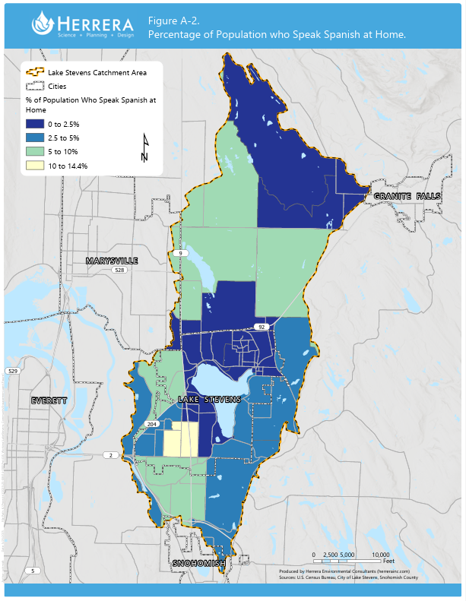
The below questions are not applicable. The limited English proficient population is less than 5%
1. Briefly describe the number of LEP persons served and languages spoken in the service area.
2. Briefly describe the frequency of contact with LEP persons for services or projects (e.g., customer service interactions, public meetings, and contracts bidding and awarding).
3. Briefly describe the importance of the program, activity, or service to the lives of LEP persons.
4. Briefly describe current resources available for LEP persons and overall cost.
4. Complaints: Provide a copy of the LPA’s Title VI complaint log, including new Title VI complaints received during this reporting period and any still pending. Include the basis of the complaint (race, color, national origin) and describe the disposition (status/outcome).
There were no complaints during this period.
5. Planning: Describe the transportation planning activities performed this reporting period. Describe the actions taken to promote Title VI compliance regarding transportation planning, including monitoring and review processes, community involvement, their outcome or status. Include examples of community outreach.
A Comprehensive Plan Update was conducted in 2024, which includes a transportation element. Public engagement for the Comprehensive Plan Update included the following:
- Public Participation Plan
  - The city adopted a Public Participation Plan (PPP) for the update.
  - This plan identified different stakeholder groups: Key Partners (e.g., Chamber of Commerce, Youth Advisory Council, affordable housing advocates, master builders, etc.) and a broader citywide audience.
  - The PPP outlined tactics: open houses, webinars, surveys, a StoryMap, meetings with key partners, and infographics.
  - The City committed to flexible, low-barrier participation (e.g., virtual options, ADA-accessible venues).
  - There was a plan for a community survey (digital, accessible, translated).
- Open Houses
  - In June 2024, the Planning Commission held two open houses at The Mill to collect public feedback:
    - June 3 — focused on Transportation and Capital Facilities. Topics included projected growth, future conditions, road classifications, active transportation, capital projects, and draft policies.
    - June 17 — focused on Land Use and Housing. Stations included potential map amendments, housing choice, affordability, recent state legislation, and equity.
  - These events were announced via the city’s news flashes / CivicAlerts.
- StoryMap
  - The city used an interactive StoryMap to introduce the plan to the public, showing existing zoning, proposed zoning changes, why changes are being considered, and how growth might occur.
  - This made the planning information more visual and accessible, especially for non-technical audiences.
  - As part of outreach, property owners within 300 feet of proposed map changes received postcards (with a QR code / link) to the StoryMap.
  - They also posted land use notice signs near areas where map amendments were proposed.
- Public Hearings
  - There were two Planning Commission public hearings: October 2, 2024, and a continuation on October 9, 2024.
  - After the Planning Commission recommended the plan, the City Council held a public hearing on October 22, 2024.
  - The hearings accepted oral testimony; there was also a mechanism for written comments through the adoption process.
- Ongoing Engagement through Key Partners
  - The PPP laid out Key Partner Meetings: early “kick-off,” mid-process check-ins, and findings feedback sessions.
  - These partner groups included community advisory groups, youth, developers, state agencies, and more.
  - The city intended to use these partners to help promote engagement (e.g., distributing surveys via their networks).
- Survey
  - A community survey was part of the strategy. It was to be hosted on the city’s comp-plan update webpage.
  - According to the PPP, the survey was to be translated (up to 3 languages) depending on accessibility needs.
- Information Materials
  - The city provided brochures and one-page summaries about the key topic areas, the process, and how people could participate.
  - The City also maintained a FAQ (Frequently Asked Questions) document for the Housing Element and Land Use Element.
  - Background analysis documents (e.g., “Audit & Gaps Analysis” of the old plan) were made available.
- Planning Commission Meetings
  - The Planning Commission met regularly (10+ meetings per the FAQ) to review drafts, hear public input, and refine recommendations.
  - Meeting minutes show discussion of public input from early outreach (e.g., survey) and suggestions to reach people “where they are” (shopping centers, neighborhoods).
- Regulatory Notices
  - The city issued a Determination of Non-significance (DNS) under SEPA on September 23, 2024.
  - There was a SEPA addendum in January 2025.
  - Map amendment notices were sent to affected property owners, as noted above (postcards, signs).
- Integration with Other Planning Processes
  - The comp plan update drew on other recent city planning work: the Housing Action Plan (adopted in 2023), Climate Sustainability Plan, subarea planning, etc.
  - By connecting with these parallel efforts, the city could leverage existing engagement networks and data.
Assessment / Observations
- Comprehensive and structured: The outreach plan was well thought out, with a formal Public Participation Plan, multiple engagement channels (in-person, online, key partners), and a feedback loop.
- Accessible & visual: Use of a StoryMap is smart — especially for land use planning which often involves maps.
- Targeted outreach: Postcards to property owners near map changes, plus in-person open houses, helps reach those who are directly impacted.
- Regulatory compliance: They did the required SEPA process and held formal public hearings.
- Equity-minded: The PPP mentions translations, accessible venues, and key partner groups to ensure diverse participation.

The Main Street Project also had a public engagement in 2025. The Main Street Project – Business Open House was held on 1/22/2025 at The Mill. It was an informative session that provided the local businesses we anticipated being potentially impacted by the project an opportunity to learn about the project and ask clarifying questions. The outreach for this event included hand delivering letters to all of the businesses between N. Lakeshore Drive and 16th St NE (on Main St).
6. Right-of-way actions: Describe activities during this reporting period associated with the purchase, sale, lease/use, or transfer of real property (related to highway transportation/public right-of-way use). Include demographic information of affected populations. For example, the race, color, national origin of affected property/business owner(s)/tenant(s).
Demographic information is not collected as part of the standard Right of Way (ROW) Acquisition process established by WSDOT. The purchase of ROW for the Main Street Project was the only completed activity during this reporting period. All activities followed the LAG Manual.
7. Identify right-of-way appraisers and acquisition staff (used during this reporting period) by race, color, national origin.
Demographic information is not collected as part of the standard Right of Way Acquisition process established by WSDOT. However, federal guidelines were used to procure the consultants.
8. Studies and Plans: Were any transportation studies (including environmental reviews) conducted or transportation plans completed during this reporting period? Identify the data source(s) and provide data summary (Title VI/Environmental Justice Analysis) relative to ethnicity, race, languages spoken, neighborhoods, income levels, physical environments, and/or travel habits. Explain how data was used in these studies/reviews/plans.
There were no transportation studies conducted or completed during this reporting period.
9. Project Location and Design: Provide a list of construction projects that began during this reporting period. Using a map of the LPAs service area, identify project locations, and a brief description of the projects’ benefits/burdens to affected populations. If possible, provide a map that overlays projects with the racial composition of affected neighborhoods.
The Main Street Project Started with a Pre-Con Meeting on 1/7/2025. Benefits of this project include increased connectivity, improved walkability, and improved multi-modal transportation. Burdens to the local area include construction and activities that created disruptions to normal operating conditions to affected businesses.
- Other Public Meetings: List other public meetings held during this reporting period. Identify efforts used to encourage citizen participation at those meetings. Detail dates, times, locations, attendance, and provide examples of outreach materials.
There were no other public meetings during this period.
- Identify members of the LPA’s transportation planning and/or advisory groups by race, color, and national origin

Not applicable.

- Specify methods used to collect demographic information from the transportation-related public meetings. (Self-identification surveys, notes by staff, etc.) Include summaries of Public Involvement Forms collected at each meeting, listing the demographics of those who attended by meeting.

Not applicable.

- List any language assistance services requested. For which languages? Who provided the service? In addition, list vital documents translated during the reporting period and identify the languages.

Not applicable.
11. Transportation-related Construction and Consultant Contracts (if applicable): Briefly describe the process used to advertise and award construction contracts during this reporting period. Include the process for negotiating contracts (e.g., consultants).
We advertised and awarded contracts per the standards in the LAG Manual. We have WSDOT-HQ acceptance and approval letters for the award of the contracts. We have a construction contract and a construction management contract for the Main Street Project.
- Describe the actions taken to promote construction contractor/consultant compliance with Title VI by construction contractors/consultants, including monitoring and review processes, and their outcomes/status (e.g. what Title VI language was included in contracts and agreements; were contractors and consultants reviewed to ensure compliance; what Title VI responsibilities are explained to contractors and consultants?)

Our advertisements include the following language around nondiscrimination:

The City of Lake Stevens, in accordance with Title VI of the Civil Rights Act of 1964, 78 Stat.252, 42 U.S.C. 2000d to 2000d-4, Title 49, Code of Federal Regulations, Department of Transportation, Subtitle A, Office of the Secretary, Part 21, Nondiscrimination in Federally assisted programs of the Department of Transportation issued pursuant to such Act, and RCW 49.60.180(1) hereby notifies all bidders that it will affirmatively ensure that in any contract entered into pursuant to this advertisement, disadvantaged business enterprises as defined at 49 CFR Part 26 will be afforded full opportunity to submit bids in response to this invitation and will not be discriminated against on the grounds of race, color, national origin, sex or sexual orientation in consideration for an award.

Our construction contracts include the following language around nondiscrimination:

Nondiscrimination. During the performance of the Work of this Agreement, the Contractor, including all subcontractors, shall comply with all applicable equal opportunity laws and/or regulations and shall not discriminate on the basis of race, age, color, sex, sexual orientation, religion, national origin, creed, veteran status, marital status, political affiliation, and/or the presence of any sensory, mental, or physical handicap. This provision shall include, but not be limited to, the following: employment, upgrading, demotion, transfer, recruitment, advertising, layoff or termination, rates of pay or other forms of compensation, selection for training, and the specifications and provisions of Work under this Agreement. This provision shall include strict compliance with all requirements of applicable federal, state, and/or local laws or regulations issued pursuant thereto and/or identified in the provisions of this Agreement, relating to the establishment of nondiscriminatory requirements in hiring and employment practices and assuring the service to the public and/or City staff without discrimination with respect to the above-listed statuses. The Contractor further agrees to maintain notices, posted in conspicuous places, setting forth provisions of this nondiscrimination clause. The Contractor understands that violation of this provision shall be cause for punitive actions by the City up to and including termination for cause of this Agreement. The Contractor may be further barred from performing any services or work for the City in the future unless and until the Contractor demonstrates to the satisfaction of the City that discriminatory practices have been eliminated and that recurrence of such discriminatory practices is unlikely.

Our Professional Services Agreements (contract for consultants) include the following language around nondiscrimination:

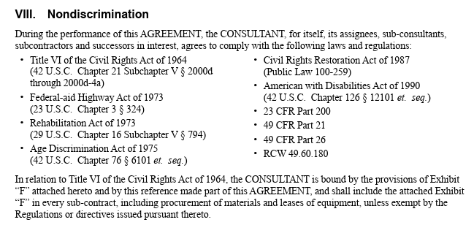

We follow the LAG Manual and follow WSDOT’s standard compliance regulations in accordance with Title VI in our contracts.

- List construction, right-of-way, and consultant contracts with your LPA/MPO/entity for this report period with dollar value of each. Identify funding sources (federal, state, local, other), and how many were awarded to certified disadvantaged contractors (as a prime contractor/consultant).
Construction Contractor for the Main Street Project - SCI : $3,076,521.71
Construction Management Contract for the Main Street Project - KBA: $411,861.00 with 19% DBE participation.
No contracts were awarded to DBE contractors during this reporting period as a prime. DBE goals were set by WSDOT and were met for sub-consultants during this reporting period.
The funding for this project included Federal Grant from FHWA at 86.5% and a local match of 13.5%.
14. Education & Training: Describe actions taken to promote Title VI compliance through education and trainings, including monitoring and review processes, and their outcomes/status.
1. List Title VI training/webinars your Title VI Coordinator attended this reporting period. Include dates and entity that conducted the training.
2. When was Title VI internal training provided to staff? Who conducted the training? What was the subject of the training? Provide the job titles and race/color/national origin of attendees.
Who Conducted the Training? | Subject | Date Training was Completed | Employee Name | Role | Race | Color | National Origin
Fair Housing Center of WA (online via NEOGOV) | Embracing Diversity, Advocating Equality | 9/20/2024 | Elijah Nico Faz | Assistant Planner | Hispanic | White | United States
Fair Housing Center of WA (online via NEOGOV) | Embracing Diversity, Advocating Equality | 9/20/2024 | Christi Schmidt | Planning Manager | White | White | United States
Fair Housing Center of WA (online via NEOGOV) | Embracing Diversity, Advocating Equality | 9/20/2024 | Tyler Farmer | Plans Examiner | White | White | United States
Fair Housing Center of WA (online via NEOGOV) | Embracing Diversity, Advocating Equality | 9/20/2024 | Ben Romanaggi | Senior Civil Engineer | White | White | United States
Fair Housing Center of WA (online via NEOGOV) | Embracing Diversity, Advocating Equality | 9/24/2024 | Aaron Halverson | Public Works Director | White | White | United States
Fair Housing Center of WA (online via NEOGOV) | Embracing Diversity, Advocating Equality | 9/24/2024 | Natasha Houghtaling | Public Works Administrative Assistant | Asian and White | White | United States
Fair Housing Center of WA (online via NEOGOV) | Embracing Diversity, Advocating Equality | 9/24/2024 | Whitney Ojalehto | Civil Engineer | White | White | United States
Fair Housing Center of WA (online via NEOGOV) | Embracing Diversity, Advocating Equality | 9/24/2024 | Kimberly Klinkers | City Engineer | White | White | United States
Fair Housing Center of WA (online via NEOGOV) | Embracing Diversity, Advocating Equality | 9/24/2024 | Lori Erickson | Public Works Analyst | White | White | United States
Fair Housing Center of WA (online via NEOGOV) | Embracing Diversity, Advocating Equality | 11/22/2024 | Gloriana Huhta | Permit Specialist | White | White | United States
 |  | 2/27/2025 | David Levitan | Principal Planner | White | White | United States

3. List other civil rights training conducted locally. Provide dates and a list of participants by job title and Title VI role, if applicable.
15. Title VI Goals for Upcoming Year
What area(s) of Title VI does your agency plan to focus on in the upcoming year? Describe by particular program area what your agency hopes to accomplish. Include any significant problem areas to focus on and plans to address those.

In the next reporting period we plan to expand related training to additional employees. The City also has a goal of expanding the availability of telephone-based interpreting services so that it is available for use by all departments in the city, on-demand.

